This Journal is © The Royal Society of Chemistry 2003

Supporting Material

The first ‘two-over/two-under’ (2O/2U) 2D weave structure assembled from Hg-containing 1D coordination polymer chains

Yun-Hui Li, Cheng-Yong Su, Andrea M. Goforth, Ken D. Shimizu, Kenneth D. Gray, Mark D. Smith, and Hans-Conrad zur Loye

Fig. S1 Packing of the interwoven layers in the structure viewed along the b direction.

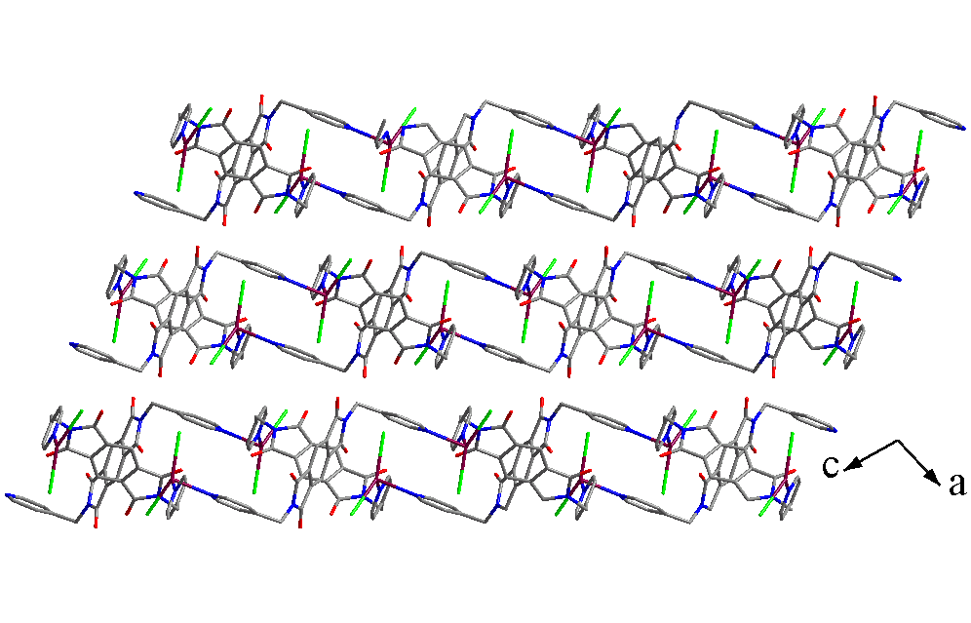
9.3 Å

